 | 
COUNCIL ASSESSMENT REPORT
SYDNEY SOUTH PLANNING PANEL

PANEL REFERENCE & DA NUMBER | PPSSSH-155  PAN-386841  DA-1470/2023
PROPOSAL | Construction of a Warehouse and Distribution Centre comprising of 5 separate units including associated site preparation works, lot amalgamation, signage, internal fit-out of units, installation of infrastructure, fencing and landscaping and use of all 5 units as warehouse or distribution centres.
ADDRESS | 1 Marple Avenue, VILLAWOOD NSW 2163
APPLICANT | OPG Pty Limited
OWNER | Marple Avenue Pty Ltd
DA LODGEMENT DATE | 27 November 2023 (submitted 3 November 2023)
APPLICATION TYPE | DA
REGIONALLY SIGNIFICANT CRITERIA | Schedule 6 – Regionally significant development of State Environmental Planning Policy (Planning Systems) 2021 as the proposal is for a general development with an estimated development cost of more than $30 million.
EDC | $47,028,650 (excluding GST)
CLAUSE 4.6 REQUESTS | None
KEY SEPP/LEP | - State Environmental Planning Policy (Biodiversity and Conservation) 2021  - State Environmental Planning Policy (Industry and Employment) 2021  - State Environmental Planning Policy (Planning Systems) 2021  - State Environmental Planning Policy (Resilience and Hazards) 2021  - State Environmental Planning Policy (Sustainable Buildings) 2022  - State Environmental Planning Policy (Transport and Infrastructure) 2021  - Canterbury Bankstown Local Environmental Plan 2023
TOTAL & UNIQUE SUBMISSIONS KEY ISSUES IN SUBMISSIONS | No submissions
DOCUMENTS SUBMITTED FOR CONSIDERATION | - Access Assessment Report (Rev. 1)  - Arboricultural Impact Assessment  - Detailed Site Investigation (E26019.E02_Rev2)  - Flooding & Stormwater Management Plan (No. R02682-SWMP)  - Flora & Fauna Assessment Report (V1)  - Geotechnical Investigation (No. 23/3481)  - Interim Audit Advice (02)  - Remediation Action Plan (E26019.E06.Rev2)
SPECIAL INFRASTRUCTURE CONTRIBUTIONS (S7.24) | None
SCHEDULED MEETING DATE | 12 August 2024
PLAN VERSION | 8 February 2024 Version No. B
PREPARED BY | Canterbury Bankstown Council
DATE OF REPORT | 5 August 2024

EXECUTIVE SUMMARY
This matter is reported to the Sydney South Planning Panel in accordance with Section 2.19 Declaration of regionally significant development: section 4.5(b) and Schedule 6 Regionally significant development of State Environmental Planning Policy (Planning Systems) 2021 as the proposed development exceeds a capital investment value of $30 million for a general development.

Development application no. DA-1470/2023 seeks consent for the construction of a warehouse and distribution facility consisting of five (5) warehouse units, each with ancillary first-floor office space. Each unit is proposed with a use of warehouse or distribution centre which is permissible with consent within the IN1 General Industrial zone. The development is provided with at-grade car parking for 76 vehicles for staff and visitors. Demolition would be sought under separate approval from this application.

The application has been assessed against the relevant provisions within State Environmental Planning Policy (Biodiversity and Conservation) 2021, State Environmental Planning Policy (Industry and Employment) 2021, State Environmental Planning Policy (Planning Systems) 2021, State Environmental Planning Policy (Resilience and Hazards) 2021, State Environmental Planning Policy (Transport and Infrastructure) 2021, Canterbury-Bankstown Local Environmental Plan 2023 (CBLEP 2023), and the Canterbury Bankstown Development Control Plan 2023. The development complies with all applicable development standards as well as all applicable planning controls except for the required setback to a riparian corridor contained within the Canterbury-Bankstown Development Control Plan 2023. This non-compliance is detailed within this report and is considered worthy of support owing to the proposal’s consistency with the desired expected outcome for this setback.

The application was referred to Ausgrid under Chapter 2 of State Environmental Planning Policy (Transport and Infrastructure) 2021. Ausgrid provided advice for any potential approvals on site. The application was referred to TfNSW under Chapter 2 of State Environmental Planning Policy (Transport and Infrastructure) 2021 with TfNSW providing conditions of consent should the application be approved. The application was referred to WaterNSW and the Natural Resource Access Regulator under the Water Management Act 2000, however both departments responded noting there were no concurrence requirements for the application.

The application was advertised and neighbour-notified for a period of twenty-one (21) days from 6 December 2023 to 17 January 2024. No submissions were made during the notification period or the assessment of the application.

A briefing was held with the Panel on 19 December 2023 where key issues were discussed, including parking, setbacks to the adjoining watercourse, flooding, and land contamination. A further briefing was held with the Panel on 22 April 2024. In this briefing, the following key issues were discussed:

Flood modelling
- Revision C of the flood report has been considered by council and lacks sufficient technical detail regarding flood modelling, including assumptions, resolution etc.
- Council has provided comments to applicant’s planner which will be reviewed by its flooding consultant and further information provided.
- Council will need 2 weeks for review, after additional information is provided.

Setback from stormwater channel
- The DCP requirement for a 15m setback is to enable a vegetation buffer adjoining the riparian corridor, which is now a concrete lined channel but has the potential for future renaturalisation of the waterway. The buildings are proposed to be setback 15m but car parking and access are within the setback with only 4-5m of landscaping.
- Council advised that to maintain the potential for renaturalisation, a 15m setback is required for batters, maintenance purposes and a potential footpath/cycleway, although the land is in private ownership and therefore the setback will only serve a landscape/ecological/amenity function.
- The applicant advised the following issues regarding setback from the channel: o car parking spaces would need to be relocated o easements and services run under the road adjoining the channel and may need to be relocated to enable a batter adjoining the channel o 10m fire brigade access is required around the building, so the building footprint may also need to be further setback.
- The Panel advised there needs to be adequate setback to achieve the objective of providing a landscape riparian buffer, and constraints and options for a greater setback than that proposed should be discussed by Council and the applicant.

Vehicle separation
- Council is seeking improved vehicle separation/circulation due to potential pedestrian, staff parking and truck drive through conflict, particularly in the southwest corner, if parking is relocated from the adjoining channel for increased landscaping.

A further briefing was held with the Panel on 1 July 2024. In this briefing it was argued by Council that some of the above matters had not been satisfactorily addressed. The Panel deferred determination and agreed to the following actions:

- The applicant shall:
  - complete a hydrographic analysis to provide evidence of an alternative solution to the management of stormwater flow through provision of an OSD system. Council is to provide the requirements for a hydrographic analysis to the applicant by 3 July;
  - provide amended plans that delete parking in the high hazard flood area and relocate or reorient where possible to satisfy the DCP requirements for warehouse parking.
  - increase the width of the landscaped setback along the watercourse to be an average of 10m;
- The applicant shall consult with council within 7 days of this meeting to ensure that the requirements to satisfy the items in 1 above are understood and agreed.
- The applicant is to provide the required information to council and upload to the Planning Portal by 22 July 2024.
- Council is requested to provide an addendum assessment report responding to the matters above, which is to be uploaded to the Planning Portal by 5 August 2024.
- When the updated assessment report is received, the Panel will determine the application by way of electronic determination.

Having adhered to the above requirements, the assessment of the proposal has been completed.

The below assessment report provides a detailed assessment of the site and its surrounds and how this development application addresses the relevant planning legislation.

- THE SITE AND LOCALITY

  - The Site

The subject site is known as 1 Marple Avenue, Villawood and has three (3) street frontages, with Llewellyn Avenue to the north, Marple Avenue to the west and Shaddock Avenue to the south. Combined, these street frontages measure approximately 631 metres in length. To the east of the site is a concrete-lined stormwater channel which forms a tributary of Prospect Creek ultimately flowing out into the Georges River. The site is an irregular shape, being narrowest to the north and widening to the south. It benefits from multiple vehicular access points on all three (3) street frontages and currently contains two (2) large and three (3) small industrial / warehouse structures, associated surface car parking as well as permitter landscaping. The site has a total land area of 40,114m², and a slope from south to north falling from 20.88 metres AHD to 16.32 metres AHD with an average gradient of 1.7%. At the northern portion of the site are three (3) existing easements for drainage. The site is flood affected both with regard to potential overflow of the adjacent stormwater channel as well as overland flow coming from the west (uphill). The site is located in an established industrial area, within walking distance of Leightonfield Railway Station. The nearest residential receptors are approximately 300 metres to the west and south.

Pursuant to clause 2.2 of Canterbury-Bankstown Local Environmental Plan 2023 (CBLEP) the site is zoned IN1 General Industrial on the Land Zoning Map. Surrounding properties are similarly zoned. Warehouse and distribution centres are a permissible form of land use within the subject IN1 General Industrial zone, and the development site is surrounded on all sides by similar land uses. The site is shown below, highlighted in blue:

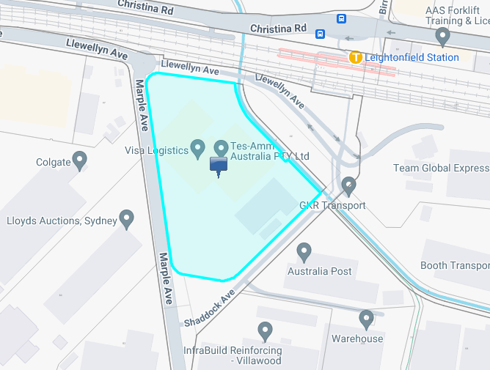
Figure 1: Location Map – Source: Weave

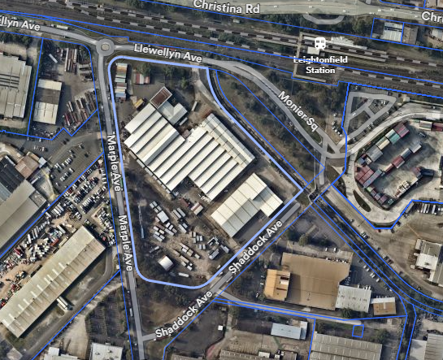
Figure 2: Aerial Image – source: NearMaps

  - The Locality

- The surrounding sites contain a range of industrial and warehouse structures and uses.
- To the north of the site is a railway corridor utilised by Sydney Trains as well as industrial traffic.
- The site is within walking distance to Leightonfield Railway Station serviced by Sydney Trains.
- The nearest residential receptors are around 300 metres to the west and to the south.

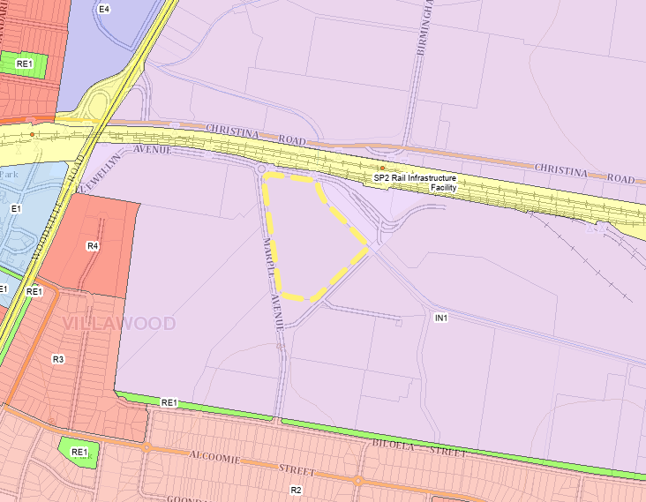
Figure 3: Land Zoning Map Excerpt – Source: Land Zoning Map
  - STORMWATER CHANNEL

Adjoining the site to the north-east boundary is a concrete-lined stormwater channel. The channel forms a tributary of Prospect Creek ultimately flowing out into the Georges River. The water in the channel flows from east to west. It originates at the intersection of Orchard Road and Marks Street in Chester Hill, approximately 1.5km to the southeast of the subject site. The channel flows through industrial land uses for the majority of its course until just after crossing under Woodville Road where it enters the Malta Street Reserve in Fairfield East shortly before flowing into Prospect Creek. An aerial of the course of the channel within Canterbury-Bankstown Council and the subject site’s positioning along the channel is shown below, with the site highlighted in yellow:

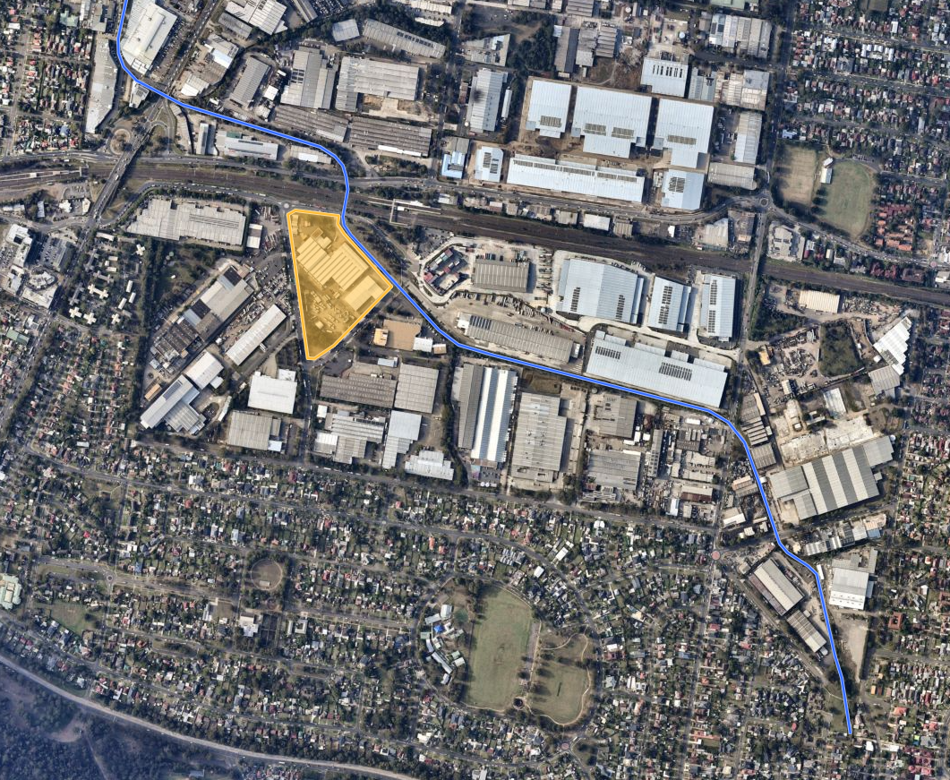
Figure 4: Stormwater Channel - Source: NearMaps
The Water Management Act 2000 defines a river as follows:

river includes—
- any watercourse, whether perennial or intermittent and whether comprising a natural channel or a natural channel artificially improved, and
- any tributary, branch or other watercourse into or from which a watercourse referred to in paragraph (a) flows, and
- anything declared by the regulations to be a river,

whether or not it also forms part of a lake or estuary, but does not include anything declared
by the regulations not to be a river.

Both the Georges River and Prospect Creek (where the subject stormwater channel connects into) satisfy the definition of a river under part (a) above. In accordance with part (b), any tributary, branch or other watercourse which flow into the Georges River or Prospect Creek also form part of the river.

Aerial imagery from 1943 provided by Six Maps shows the site and the stormwater channel. The street layout has been shown with black lines for a frame of reference:

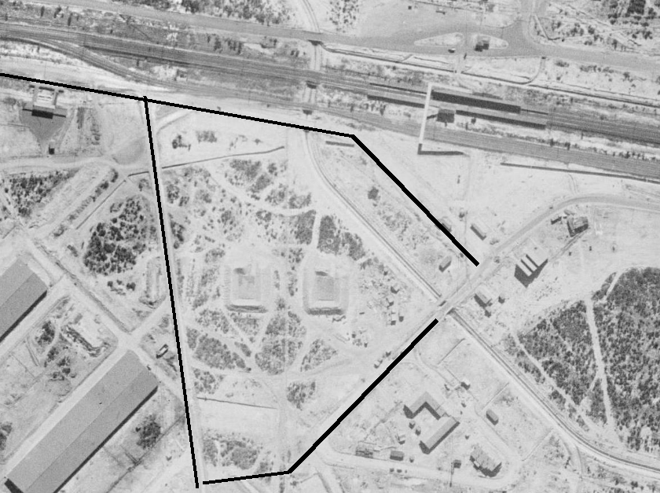
Figure 5: 1943 Aerial imagery - Source: SixMaps
As can be seen above, the stormwater channel has been enhanced through concrete lining. Notwithstanding this enhancement, an analysis of aerial imagery of the channel shows that there is a continuous flow of water, regardless of time of year.

July 2019 | 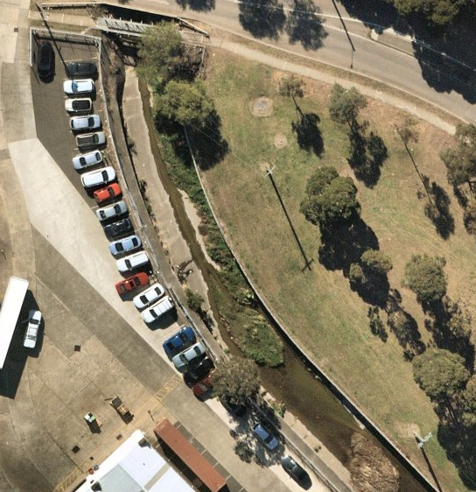
January 2020 | 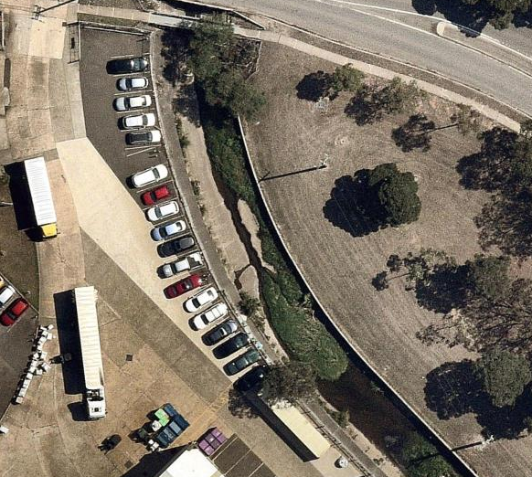
December 2020 | 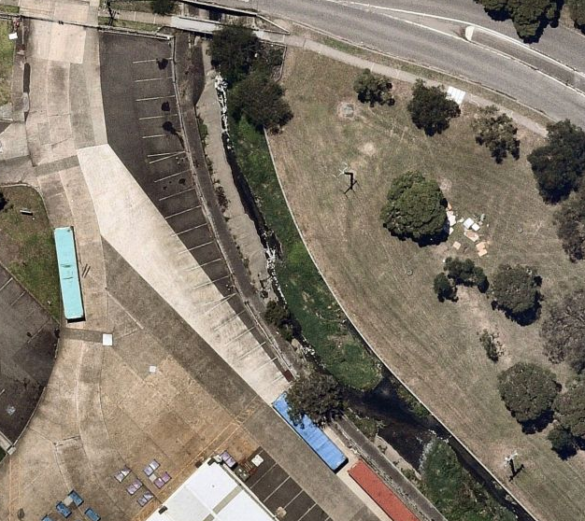
August 2021 | 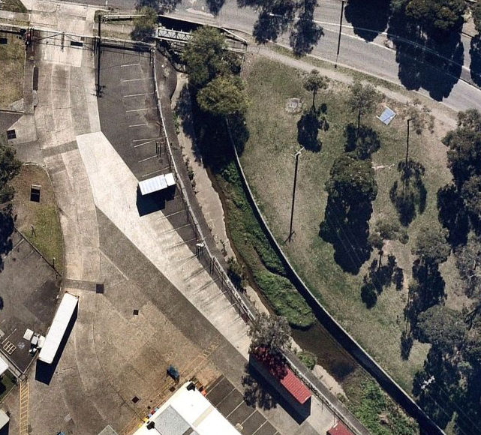
February 2022 | 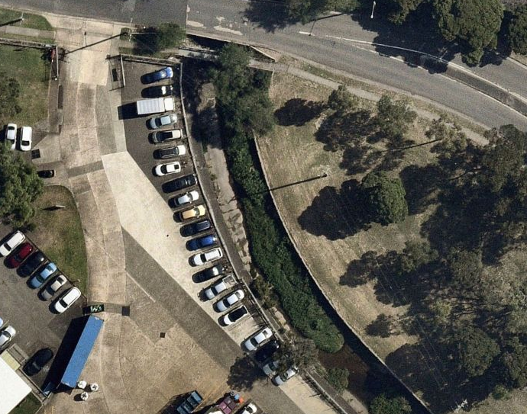
October 2022 | 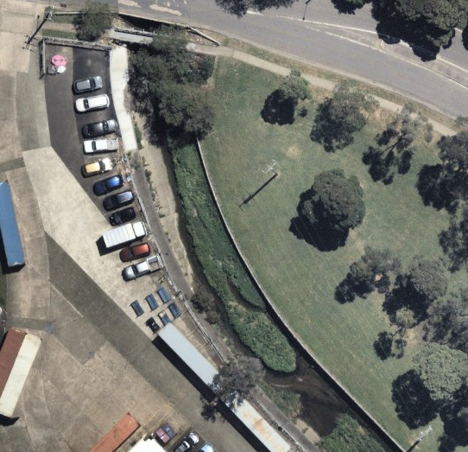
January 2024 | 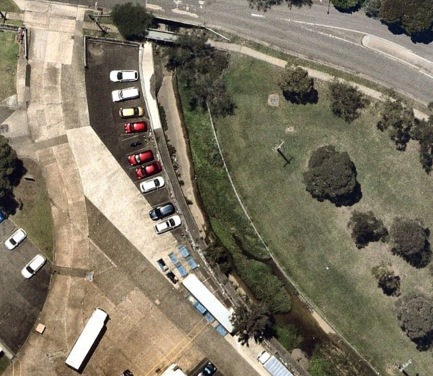
May 2024 | 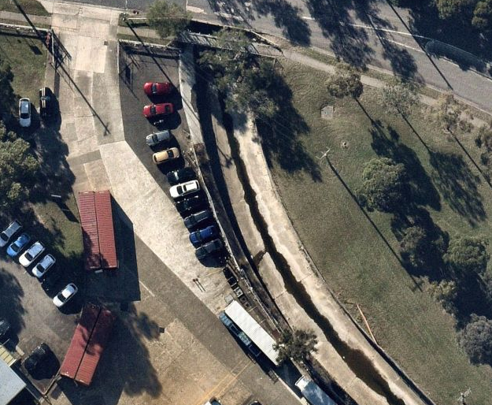

The continuous flow of water demonstrates that this is a natural waterway which drains a specified catchment in order to transport water into Prospect Creek (a river). Accordingly, the stormwater channel cannot be classified as a minor stream.

The Water Management (General) Regulation 2018 provides the following definition for a minor stream:

minor stream means—
- any stream or part of a stream—
  - the location of which is specified in the hydroline spatial data, and
  - that is identified as a first or second order stream, or part of such a stream, as determined in accordance with the system set out in Schedule 2, and
  - that does not maintain a permanent flow of water, being a visible flow that occurs on a continuous basis, or would so occur if there were no artificial abstractions of water or obstruction of flows upstream, and
  - that does not at any time carry flows emanating from a third or higher order stream as determined in accordance with the system set out in Schedule 2, or
- any stream or part of a stream the location of which is not specified in the hydroline spatial data.

For the purposes of paragraphs (a)(i) and (b), a stream is specified in the hydroline spatial data if it is identified as a watercourse (however described) in accordance with the legend or terms of that data.

A map showing the origin location of the channel in relation to the subject site is shown below, with the site highlighted in yellow:

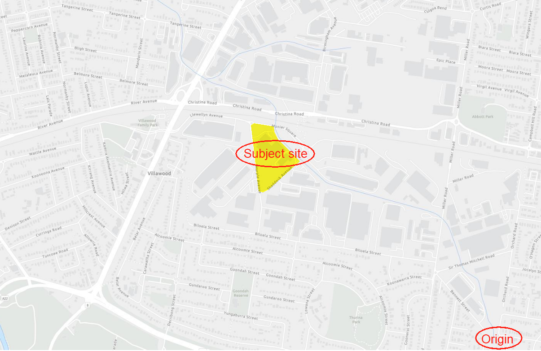
Figure 6: Stormwater Channel - Source: Hydroline Spatial Data Map
As seen above, the channel is displayed on the Hydroline Spatial Data Map. Hydro Line spatial data contains mapped information about watercourses and waterbodies in New South Wales. It is based on the Spatial Services (Department of Finance, Services & Innovation) NSW Hydro Line dataset. The purpose of the Hydro Line spatial data is to determine the Strahler stream order of a stream. Using the Strahler stream order (stream order map below):

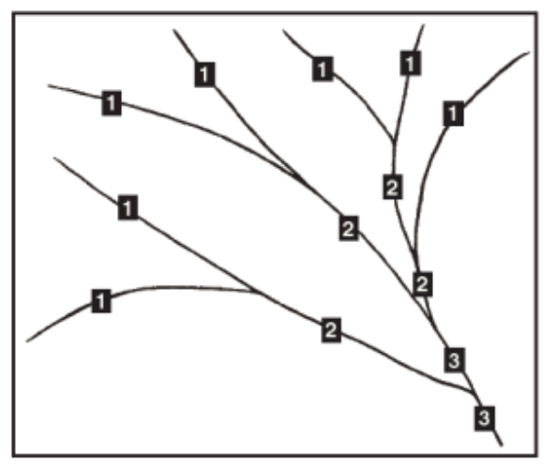

Using the Strahler stream order map it can be seen that the subject stormwater channel is a 1st order waterway, with Prospect Creek being 2nd order and the George River being 3rd order. As discussed above, the channel contains a continuous flow of water and so while it satisfies all other criteria to be classed as a minor stream, it fails in the definition part (a)(iii). The channel is therefore best classified as a river in accordance with the Water Management Act 2000.

The channel has been significantly impacted by developments, both more recent and historic. Within the immediate vicinity of the subject site, the following properties adjoin the channel, with discussions of their impacts on the channel being provided below:

- 220-246 Miller Road, Villawood
This site contains an industrial and warehouse development which was approved in 2020 (DA-632/2019) and is located on the northern bank of the channel. Setbacks to the northern bank of the channel range from nil to 2 metres with riparian plantings located where appropriate. The setback is shown below, highlighted in green:

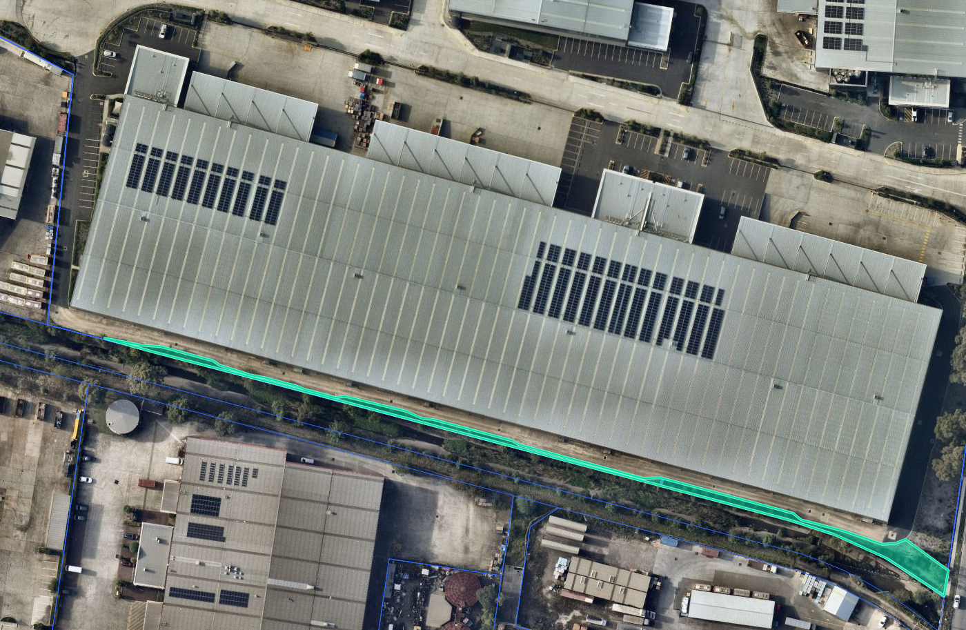

This application was accompanied by a Riparian Management Advice report which detailed that the proposal would provide for improved habitat value, an improved ground layer and increase native plant diversity. The report was reviewed by Council’s Biodiversity Officer who accepted the advice. This DA was approved under delegated authority.

- 3 Monier Square, Villawood
This site (which immediately adjoins 220-246 Miller Road to the west and is also located on the northern bank of the channel) contains an industrial facility which was last amended through DA-900/2016 which permitted the extension of an existing awning. The site provides a nil setback to the northern bank of the stormwater channel, with the site shown below highlighted in pink:

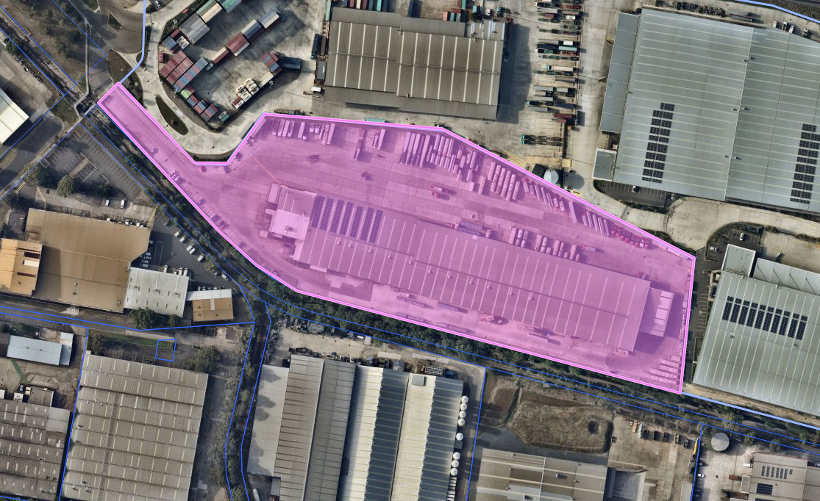

- 44 Biloela Street, Villawood
This site (which sits on the southern bank of the channel opposite 220-246 Miller Road and 3 Monier Square) contains an industrial facility with an extension to the rear (towards the stormwater channel) approved in 2024 (DA-231/2024) which provides for a 2-metre setback to the channel. This extension is yet to be constructed, but the approved setback to the southern bank of the stormwater channel can be seen below, highlighted in green:

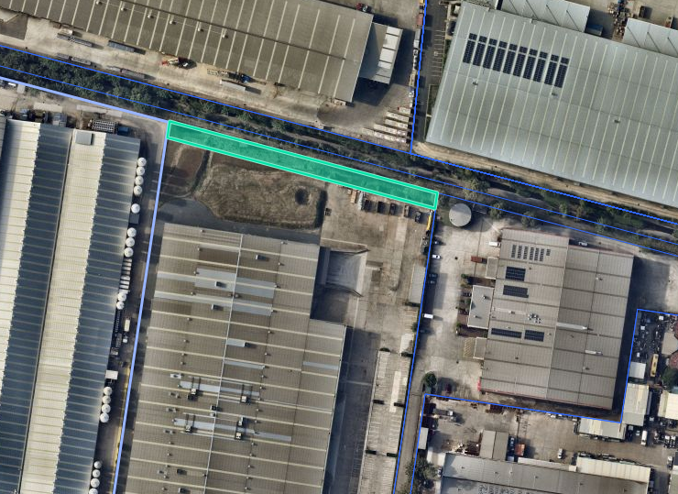

- 64 Biloela Street, Villawood
This site (which sits to the west of 44 Biloela Street on the southern bank of the channel) contains an industrial facility last added to through DA-1440/2003. The development provides a nil setback to the southern bank of the stormwater channel.

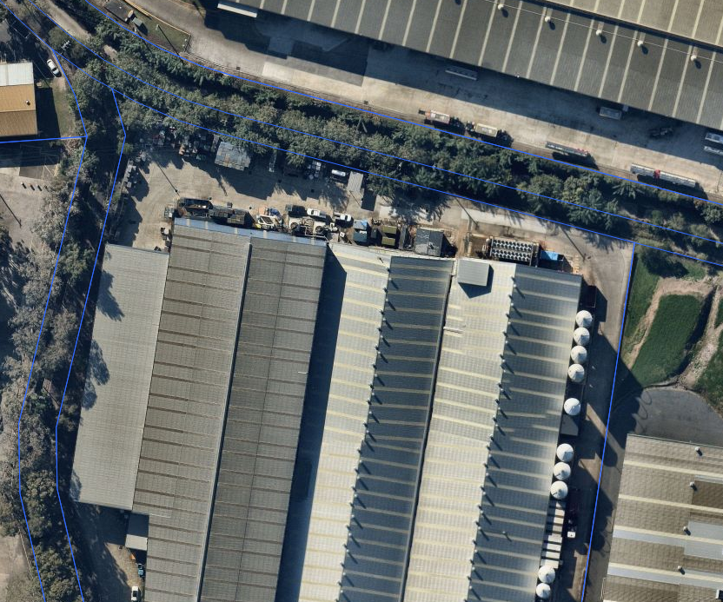

- 15 Shaddock Avenue, Villawood
This site contains an industrial facility which was last added to with an awning DA approved in 2001. The site provides for a nil setback to the southern bank of the stormwater channel.

- 2Z Monier Square, Villawood
This site contains no structures and is entirely vegetated but accommodates electricity transmission poles and wires. It directly adjoins the north bank of the stormwater channel, across from the subject site. This site is owned by Council who has future aspirations to use this site for a stormwater retention facility which will capture water from upstream and slowly release it downstream. This facility is necessitated by a bottleneck in the stormwater channel which exists immediately downstream where the channel passes underneath the adjacent railway corridor, Llewellyn Avenue and Christina Road, where the width of the channel is constrained. The location of this piece of land can be seen below, highlighted in green, with the subject site highlighted in yellow:

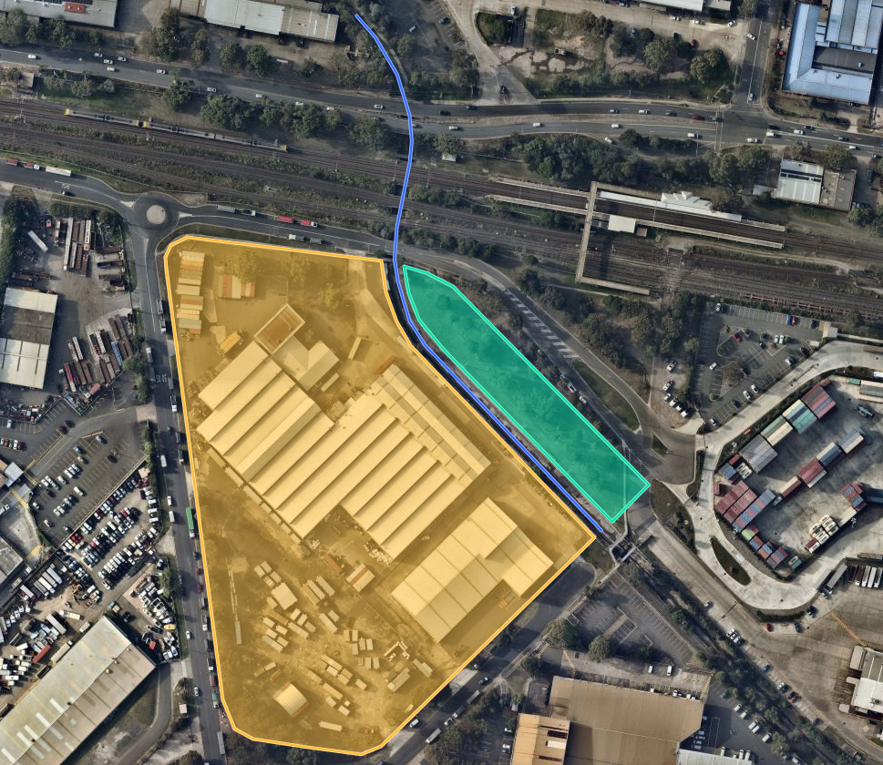

As can be seen above, the river adjoins a number of industrial developments which provide a range of setbacks though most sites provides nil setbacks.

- THE PROPOSAL AND BACKGROUND

  - The Proposal

The application proposes the construction of a warehouse and distribution centre comprising of 5 (five) separate units including associated site preparation works, lot amalgamation, signage, internal fit-out of units, installation of infrastructure, fencing and landscaping as well as the of all five units for warehouse or distribution centres with 24/7 operations.

- The application proposes a development with an FSR of 0.46:1 and a maximum building height of 15.7 metres, both of which are consistent with the existing and future desired character of the industrial area.
- The application proposes to maintain and or repair existing vehicle footway crossings (VFCs) to the surrounding road network.
- 3D depictions of the development are provided below:

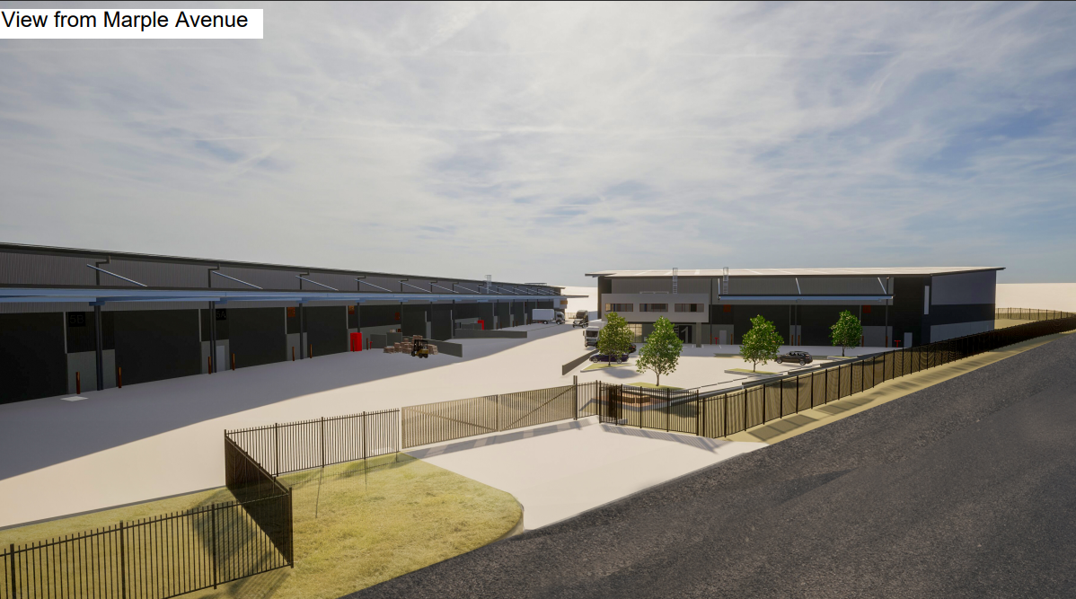

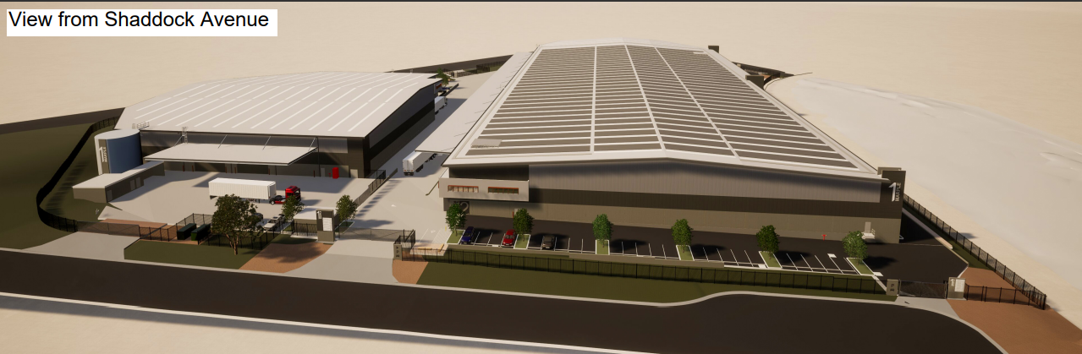

A summary of the proposed development details is provided below in Table 1:

Table 1: Development Data
Control | Proposal
Site area | 40,114m²
GFA | 18,414m²
FSR | 0.46:1 where 1:1 is permitted
Clause 4.6 Requests | No
Max Height | 15.7 metres
Landscaped area | 6,110m²
Car Parking spaces | 76
Setbacks | 10 metre setbacks from street boundary

A breakdown of individual warehouse proposals is provided below in Table 2. Each unit is proposed to be a warehouse or distribution centre with permanent (i.e. 24 hours per day and seven days per week) operations.

Table 2: Warehouse Specifics
Warehouse | Ground Floor | Mezzanine / Office
1 | 4260.0m² | 200.0m²
2 | 3547.0m² | 189.0m²
3 | 2908.0m² | 194.0m²
4 | 3060.0m² | 189.0m²
5 | 3681.0m² | 197.0m²

  - Background

A pre-lodgement meeting was held on 1 December 2022 where various issues were discussed. A summary of the key issues and how they have been addressed by the proposal is outlined below:

- Requirement to obtain a Stormwater Systems Report from Council

Comment: A stormwater systems report was procured by the applicant The development has been designed in accordance with the requirements of this report, and conditions of consent have been provided by Council’s Assets division.

- Requirement to submit a flood impact assessment to demonstrate that the development is compatible with the flood-risk on site.

Comment: The development is accompanied by sufficient information and conditions of consent have been provided by Council’s Assets division.

- Requirement to submit detailed hydraulic modelling.
Comment: The development is accompanied by sufficient information and conditions of consent have been provided by Council’s Assets division.

- Requirement for the provision of on-site detention (OSD).

Comment: Council’s Development Engineer has agreed that an OSD system is not required for this development. Conditions of consent have been provided by the Development Engineer.

- Requirement to adhere to CBDCP 2023’s 15 metre setback to a riparian corridor.

Comment: Council has agreed that an average setback of 7.9metres with certain sections in excess of 15 metres is a suitable outcome which demonstrates consistency with the anticipated purpose of the setback which is to provide a naturally landscaped setback to a riparian corridor.

- Requirement to provide parking at the industrial land use rate (1:100).

Comment: Council has agreed that with the use of the units for warehouse or distribution functions, a parking rate of 1:300 (warehouse rate) is appropriate subject to conditions of consent.

The development application was lodged on 27 November 2023. A chronology of the development application since lodgement is outlined below including the Panel’s involvement (briefings, deferrals etc) with the application:

Table 3: Chronology of the DA
Date | Event
27 November 2023 | DA lodged
6 December 2023 | Exhibition of the application
6 December 2023 | DA referred to external agencies
15 January 2024 | Request for Information from Council to applicant
19 December 2023 | Panel briefing
19 March 2024 | Amended plans lodged
22 April 2024 | Assessment briefing
14 May 2024 | Meeting between Council and the Applicant to discuss matters raised within April assessment briefing.
1 July 2024 | Assessment briefing
12 August 2024 | Determination briefing

- STATUTORY CONSIDERATIONS

When determining a development application, the consent authority must take into consideration the matters outlined in Section 4.15(1) of the Environmental Planning and Assessment Act 1979 (‘EP&A Act’). These matters as are of relevance to the development application include the following:

- the provisions of any environmental planning instrument, proposed instrument, development control plan, planning agreement and the regulations
(i) any environmental planning instrument, and
(ii) any proposed instrument that is or has been the subject of public consultation under this Act and that has been notified to the consent authority (unless the Planning Secretary has notified the consent authority that the making of the proposed instrument has been deferred indefinitely or has not been approved), and
(iii) any development control plan, and
(iiia) any planning agreement that has been entered into under section 7.4, or any draft planning agreement that a developer has offered to enter into under section 7.4, and
(iv) the regulations (to the extent that they prescribe matters for the purposes of this paragraph),
that apply to the land to which the development application relates,
- the likely impacts of that development, including environmental impacts on both the natural and built environments, and social and economic impacts in the locality,
- the suitability of the site for the development,
- any submissions made in accordance with this Act or the regulations,
- the public interest.

In this regard, the following environmental planning instruments, development control plans, codes and policies are relevant and considered below:

- State Environmental Planning Policy (Biodiversity and Conservation) 2021
- State Environmental Planning Policy (Industry and Employment) 2021
- State Environmental Planning Policy (Planning Systems) 2021
- State Environmental Planning Policy (Resilience and Hazards) 2021
- State Environmental Planning Policy (Transport and Infrastructure) 2021
- Canterbury-Bankstown Local Environmental Plan 2023 (CBLEP 2023)
- Canterbury-Bankstown Development Control Plan 2023 (CBDCP 2023)
- Canterbury-Bankstown Local Infrastructure Contributions Plan 2022

These matters are further considered below.

It is noted that the proposal is not considered to be:

- Integrated Development (s4.46)
- Designated Development (s4.10)
- Requiring concurrence/referral (s4.13)
- Crown DA (s4.33)

  - Environmental Planning Instruments, proposed instrument, development control plan, planning agreement and the regulations

The relevant environmental planning instruments, proposed instruments, development control plans, planning agreements and the matters for consideration under the Regulation are considered below.

Water Management Act 2000
The proposal was referred to both Water NSW and the Department of Planning and Environment – Water for concurrence in accordance with Section 90(2) and 91 of the Water Management Act 2000, due to the sites location in proximity to a water course.

Both Water NSW and Department of Planning and Environment – Water have reviewed the proposal and documentation submitted and advised that no approvals are required as part of the development application.

- Section 4.15(1)(a)(i) - Provisions of Environmental Planning Instruments

The following Environmental Planning Instruments are relevant to this application.

- State Environmental Planning Policy (Biodiversity and Conservation) 2021
- State Environmental Planning Policy (Industry and Employment) 2021
- State Environmental Planning Policy (Planning Systems) 2021
- State Environmental Planning Policy (Resilience and Hazards) 2021
- State Environmental Planning Policy (Sustainable Buildings) 2022
- State Environmental Planning Policy (Transport and Infrastructure) 2021
- Canterbury Bankstown Local Environmental Plan 2023

A summary of the key matters for consideration arising from these State Environmental Planning Policies are outlined in Table 3 and considered in more detail below.

Table 4: Summary of Applicable Environmental Planning Instruments
EPI | Matters for Consideration | Comply (Y/N)
State Environmental Planning Policy (Biodiversity & Conservation) 2021 | Chapter 2: Vegetation in non-rural areas  - Part 2.2 Clearing vegetation in non-rural areas: the development proposes the removal of vegetation on site which is considered suitable subject to replacement plantings by Council’s Tree Management Officer.  Chapter 6: Water catchments  - Part 6.2 Development in regulated catchments: the application is accompanied by sufficient information to satisfy Council with regard to this development in a regulated catchment. | Y
State Environmental Planning Policy (Industry and Employment) 2021 | Chapter 3: Advertising and Signage  - Part 3.2 Signage generally: the signage proposed is consistent with the aims of Chapter 3.  - Schedule 5 Assessment criteria: the signage proposed is considered suitable in accordance with an assessment against relevant criteria. | Y
State Environmental Planning Policy (Planning Systems) 2021 | Chapter 2: State and Regional Development  - Part 2.4 Regionally significant development: in accordance with the criteria of Schedule 6, the development proposed is of regional significance, being a general development with an estimated development cost more than $30 million. | Y
State Environmental Planning Policy (Resilience and Hazards) 2021 | Chapter 4: Remediation of Land  - Section 4.6 Contamination and remediation to be considered in determining development application: the subject site is zoned IN1 General Industrial, with a history of various industrial activities. A detailed site investigation report accompanies this application which concludes that soil samples analysed had potential for contamination. Accordingly, a remediation action plan was prepared for the site which determined by Council’s Environmental Health Officer that subject to recommendations, the site can be made suitable for the development. | Y
State Environmental Planning Policy (Transport and Infrastructure) 2021 | Chapter 2: Infrastructure  - Division 5 Electricity transmission or distribution: the application was referred to Ausgrid who provided advice for any future development on the site.  - Division 15 Railways: the application was referred to Transport for New South Wales who provided conditions of consent for a future development on the site.  - Division 17 Roads and traffic: the application was referred to Transport for New South Wales who provided comment that the development was not expected to provide for impacts on the surrounding classified roadway network as a traffic-generating development. | Y
Proposed Instruments | There are no proposed instruments applicable to the subject site or the development typology. | N/A
CBLEP 2023 | - Clause 1.2 – Aims of plan: the development is consistent with the aims of the plan, regarding contributing to the sustainability of Canterbury-Bankstown, protection landforms and enhancing vegetation, restricting development on land subject to natural hazards and the provision of good urban design.  - Clause 4.3 – Height of buildings: no height of building restriction applies within the map; however the development is consistent with objectives of the clause.  - Clause 4.4 – Floor space ratio: the development complies with the maximum permitted FSR.  - Clause 5.21 – Flood planning: sufficient information has been submitted to determine the suitability of the proposal as demonstrated through the conditions of consent provided by Council’s Assets division.  - Clause 6.2 – Earthworks: sufficient information has been submitted to determine the suitability of the proposal with regard to potential impacts of earthworks on flooding characteristics of this site as demonstrated by conditions of consent provided by Council’s Assets division.  - Clause 6.4 – Biodiversity: the site is not subject to the Terrestrial Biodiversity Map.  - Clause 6.15 – Design excellence: the development is consistent with the objective of this clause. | Y
CBDCP 2023 | - Chapter 2.2 – Flood Risk Management: the application is accompanied by sufficient information to demonstrate a suitable outcome.  - Chapter 2.3 – Tree Management: The application proposes the removal of vegetation which is considered suitable subject to replacement plantings.  - Chapter 3.1 – Development Engineering Standards: The application does not propose on-site stormwater detention and this is considered a suitable outcome in this instance owing to the information supplied in support of this application.  - Chapter 3.2 – Parking: The application proposes a lower rate of parking than would be provided for the highest and best use of the site but can be an appropriate outcome.  - Chapter 3.3 – Waste Management: The development generally complies with requirements.  - Chapter 3.6 – Signs: The application complies with requirements.  - Chapter 3.7 – Landscape: The application generally complies with requirements, offering an alternate and acceptable solution to strict compliance.  - Chapter 9.1 – Industrial Precincts: The application generally complies except for the proposed variation to the required setback to a riparian corridor where a variation is considered suitable in this instance for reasons outlined below. | Y

Consideration of the relevant SEPPs is outlined below:

State Environmental Planning Policy (Biodiversity and Conservation) 2021

Chapter 2 of SEPP (Biodiversity) aims to protect the biodiversity values of trees and other vegetation in non-rural areas of the State, and to preserve the amenity of non-rural areas of the State through the preservation of trees and other vegetation. Chapter 2 applies to the whole of Canterbury Bankstown Council, including the subject development site.

The total canopy cover of the trees proposed for removal is approximately 399m². The accompanying Arboricultural Impact Assessment has identified two (2) trees proposed for removal to have high retention values, two (2) trees proposed for removal to have medium retention values and one (1) tree proposed for removal to have a low retention value. The Arboricultural Impact Assessment has concluded that none of the trees proposed for removal are significant from a biodiversity perspective.

The Arboricultural Impact Assessment has been reviewed by Council’s Tree Management Officer who has concluded that removal of the vegetation is suitable for the site and consistent with the aims of SEPP (Biodiversity and Conservation) 2021 subject to replacement tree planting conditions which have been included within the accompanying conditions of consent.

Chapter 6 of SEPP (Biodiversity) applies to all development on land in a regulated catchment. Canterbury Bankstown Council includes land within the Georges River Catchment, in which the subject site falls. This chapter has no specific objectives but requires the consent authority to consider a number of matters which are addressed below:

Section 6.6 Water quality and quantity

- The application will have a neutral effect on the quality of water entering the adjoining waterway.
- The application is accompanied by sufficient information in order to determine that the flow of water within the adjoining waterway will not be impacted, primarily as a result of potential excess stormwater run-off from this site.
- The application has supplied sufficient information to determine that the development will not provide for an increase in stormwater run-off compared to what exists on site today.
- The application is not expected to have any impact on the level or quality of the water table.
- The application is accompanied by sufficient information to determine the cumulative environmental impacts of the development on the catchment.
- The development would have a neutral impact on the quality and quantity of ground water.
- The development is expected to have a neutral impact on the quality of water entering the adjoining waterway.
- The application is accompanied by sufficient information to determine the impacts to the water flow within the adjoining waterway.

Section 6.7 Aquatic ecology

- The development is not expected to provide for an impact on aquatic ecology, noting that the adjoining waterway has been concrete-lined and is not yet re-naturalised.

Section 6.8 Flooding

- No use is proposed through this application and accordingly, in the event of a flood, it is not expected that pollutants would be released into the waterway.
- The development would not have an impact on the recession of floodwaters into wetlands as no wetlands border the site.

Section 6.9 Recreation and public access

- The development will provide no impact on recreation or public access.
Section 6.10 Total catchment management

- Consultation with downstream councils has not been undertaken as it has not been demonstrated to what effect, if any, the development will have on the flow of water downstream to the subject site.

Section 6.11 Land within 100m of natural waterbody

- There is no definition within the subject SEPP, any other EPI or Act which defines a “natural waterbody.”

As detailed within this report, the adjoining stormwater channel contains a consistent flow of water, connecting to a river. While the channel has been artificially modified, its purpose is the regular flow of water, meaning that the channel is a natural waterbody.

Section 6.11 requires the consent authority to consider whether the proposed uses are of a water-dependent nature. No definition of ‘water-dependent’ is provided and no land use is proposed through this application, however it is considered that a potential future warehouse land use would be suitable for the site and not dependent on water, particularly from the adjoining channel.

The section also requires the consent authority to consider whether conflicts between land uses are minimised. The proposal is not considered likely to bring about conflicts between land uses, noting that all surrounding sites are similarly zoned and no land along the waterbody is zoned for recreational purposes.

Section 6.17 Heavy and hazardous industries

- No use of the development is proposed.

In light of the above comments, a full and comprehensive assessment to determine the suitability of the proposed development and its impact upon the adjoining stormwater channel is unable to be undertaken.

State Environmental Planning Policy (Industry and Employment) 2021

The proposal seeks consent for the installation of site signage to identify the development and its future uses when viewed from the surrounding roadways. An assessment of the signage against the aims and objectives of Chapter 3 of State Environmental Planning Policy (Industry and Employment) 2021 has revealed that the building / site identification signs are compatible with the character of the area, provide effective communication and are of high quality design.

The signage is consistent with the specified criteria in Schedule 5 of State Environmental Planning Policy (Industry and Employment) 2021 and that the signage is suitable for the site and the locality in general, being consistent with the expected and desired outcome for the area.

State Environmental Planning Policy (Planning Systems) 2021

Clause 2.19(1) of Part 2.4 of SEPP (Planning Systems) 2021 reads as follows;

Development specified in Schedule 6 is declared to be regionally significant development for the purposes of the Act.

Schedule 6 of SEPP (Planning Systems) 2021, in part, reads;

2 General development over $30 million

Development that has a capital investment value of more than $30 million.

The CIV of the proposed development exceeds $30 million ($47,028,650.00). The development therefore qualifies as being a ‘regionally significant development’ and the Sydney South Planning Panel are the determining authority.

State Environmental Planning Policy (Resilience and Hazards) 2021

Chapter 4: Remediation of Land

The provisions of Chapter 4 of State Environmental Planning Policy (Resilience and Hazards) 2021 have been considered in the assessment of the development application. Section 4.6 of the SEPP requires consent authorities to consider whether the land is contaminated, and if the land is contaminated, it is satisfied that the land is suitable in its contaminated state (or will be suitable, after remediation) for the purpose for which the development is proposed to be carried out. In order to consider this, a Detailed Site Investigation (‘DSI’) has been prepared for the site.

The DSI provides the following key findings:

  - The site had continuously been used for a variety of industrial purposes since at least the 1950’s.
  - On site activities include metal fabrication.
  - Soil sampling of site found the presence of asbestos.
  - Certain soil samples indicate that there is residual petroleum hydrocarbons present on site.

The DSI concluded that gross or widespread contamination was not present however, certain data gaps remained which required closure of the land which could be considered

Accordingly, a draft Remediation Action Plan (RAP) has been prepared for the site. The RAP recommends six (6) stages of remediation, being:

- Preliminaries and site establishment,
- Surface inspection,
- Data gap investigation and waste classification,
- Remedial excavation and validation of impacted soils and USTs,
- Final surface inspection, and
- Validation report preparation.

Council’s Environmental Health Officer has reviewed the development application and its accompanying documentation and considered that subject to the recommendations of the submitted reports and further onsite investigations, the site can be made suitable for its intended purpose.

Having regard to the assessment set out above, the Panel can be satisfied that the development site is suitable for the proposed development, in accordance with clause 4.6(1) of SEPP (Resilience and Hazards) 2021.

State Environmental Planning Policy (Transport and Infrastructure) 2021

State Environmental Planning Policy (Transport and Infrastructure) 2021 (TISEPP) aims to facilitate the effective delivery of infrastructure across the State. Chapter 2 of State Environmental Planning Policy (Transport and Infrastructure) 2021 applies to infrastructure and aims to facilitate the effective delivery of infrastructure across the State. The following divisions apply to this application:

Division 5 Electricity transmission or distribution
Subdivision 2 – Development likely to affect an electricity transmission or distribution network.

This section applies to development or modification applications which include:
- Penetration of ground within 2 metres of an underground power line
- Works within 10 metres of any part of an electricity tower
- Works immediately adjacent to a substation.
- Works immediately adjacent to an electricity easement.
- Works within 5m of an overhead power line
- Installation of a pool within 30 metres of supporting overhead electricity transmission lines or within 5 metres of overhead power lines

Council referred the application to Ausgrid on 21/11/2023. Ausgrid have provided conditions of consent which incorporated into the accompanying conditions of consent.

Division 15 Railways
Subdivision 2 Development in or adjacent to rail corridors and interim rail corridors—notification and other requirements
2.98 Development adjacent to rail corridors

This section applies to development on land that is adjacent to a rail corridor and:

- Is likely to have adverse effects on rail safety, or
- Involves placing metal finishes on a structure, or
- Involves the use of a crane, or
- Is within 5 metres of overhead electricity power lines used for the railways.

Council referred the application to TfNSW on 21/11/2023. TfNSW have provided conditions of consent which incorporated into the accompanying conditions of consent.

Division 15 Railways
Subdivision 2 Development in or adjacent to rail corridors and interim rail corridors—notification and other requirements
2.99 Excavation in, above, below or adjacent to rail corridors

This section applies to development on land that is adjacent to a rail corridor where:

- Excavations of at least 2 metres in depth and which are within 25 metres of a rail corridor are proposed.

Council referred the application to TfNSW on 21/11/2023. TfNSW have provided conditions of consent which incorporated into the accompanying conditions of consent.

Division 17 Roads and traffic
Subdivision 2 Development in or adjacent to road corridors and road reservations
2.122 Traffic-generating development

This section applies to new premises of the relevant size or capacity and enlargement of existing premises if the enlargement of the relevant size and capacity (Schedule 3).

Council referred the application to TfNSW on 21/11/2023. TfNSW have provided comment that the development is not expected to provide impacts on the nearby classified road network.

Canterbury Bankstown Local Environmental Plan 2023
The relevant local environmental plan applying to the site is the Canterbury Bankstown Local Environmental Plan 2023 (‘the LEP’).

Aims

The aims of the LEP include:

- to manage growth in a way that contributes to the sustainability of Canterbury-Bankstown,
- to protect landforms and enhance vegetation, especially foreshores and bushland, in a way that maintains the biodiversity values and landscape amenity of Canterbury-Bankstown,
- to restrict development on land that is sensitive to urban and natural hazards,
- to provide a range of business and industrial opportunities to encourage local employment and economic growth and retain industrial areas,
- to achieve good urban design in terms of site layouts, building form, streetscape, architectural roof features and public and private safety,
- to consider the cumulative impact of development on the health of the natural environment and waterways and on the capacity of infrastructure and the road network,
- to ensure development is accompanied by appropriate infrastructure,

The proposal is consistent with the aims of the LEP and is considered to provide for protection of the environment and needed industrial land within the metropolitan region.

Zoning and Permissibility

The site is zoned IN1 General Industrial pursuant to clause 2.2 of the LEP.

The proposed land use of warehouse and distribution centre is a permissible form of development within the zone.

According to the definitions in Clause 4 (contained in the Dictionary), the proposal satisfies the definition of warehouse and distribution centre which is a permissible use with consent in the Land Use Table in Clause 2.3.

The zone objectives include the following (pursuant to the Land Use Table in Clause 2.3):

- To provide a wide range of industrial and warehouse land uses.
- To encourage employment opportunities.
- To minimise any adverse effect of industry on other land uses.
- To support and protect industrial land for industrial uses.
- To promote a high standard of urban design and local amenity.

The proposal is considered to be consistent with these objectives through the provision of warehouse land uses which will encourage employment within the area and protect industrial land uses for future generations. The design of the development promotes a high standard or urban design and local amenity.

General Controls and Development Standards

The LEP also contains controls relating to development standards, miscellaneous provisions and local provisions. The controls relevant to the proposal are considered in Table 4 below.

Table 5: Consideration of the LEP Controls
Control | Requirement | Proposal | Comply
Height of buildings  (Cl 4.3(2)) | No standard | 15.7 metres | Yes
FSR  (Cl 4.4(2)) | 1:1 | 0.46:1 | Yes
Cl. 5.21  Flood Planning | Minimise flood risk to life and property, avoid adverse cumulative impacts on flood behaviour. | Sufficient information has been provided to demonstrate that the proposal would not provide adverse impacts on flood behaviour. | Yes
Cl. 6.2  Earthworks | Ensure that earthworks will not have a detrimental impact on environmental functions and processes, neighbouring uses. | Sufficient information has been provided with regard to the proposed fill and how the fill would not alter the flooding characteristics of the site. | Yes
Cl. 6.4  Biodiversity | Protection of native flora and fauna. | Proposed removal of vegetation on site is suitable subject to replacement plantings as indicated in accompanying landscape plan. | Yes
6.15  Design excellence | Ensure that development exhibits high quality architectural, urban and landscape design | The proposal utilises high-quality materials and finishes and provides a defied corner presentation to the primary façade of the development. | Yes

The proposal is considered to be generally inconsistent with the LEP.

- Section 4.15 (1)(a)(ii) - Provisions of any Proposed Instruments

There are no applicable proposed instruments.

- Section 4.15(1)(a)(iii) - Provisions of any Development Control Plan

The following Development Control Plan is relevant to this application:

Canterbury Bankstown Development Control Plan 2023 (‘the DCP’)

Table 5: Consideration of the DCP Controls
Control | Requirement | Proposal | Comply
Chapter 2.2  3.1  Flooding | The proposed development should not result in any significant increase in risk to human life, or in a significant increase in economic or social costs as a result of flooding. | The application is accompanied by sufficient information and conditions of consent have been recommended which demonstrate no increase to life or property as a result of the development in a flood zone. | Y
Chapter 2.2  3.3  Flooding | Development should not significantly increase the potential for damage or risk other properties either individually or in combination with the cumulative impact of development that is likely to occur in the same floodplain. | Information to demonstrate that the development would not bring about adverse impacts on flood behaviour has been provided. . | Y
Chapter 3.1  3.1  Development impacted by stormwater systems | Applicants must apply to Council for a Stormwater System Report (SSR), prior to DA submission, if the site is noted on Council's SSR register as affected by Council's stormwater drainage pipelines and/or affected by potential local stormwater flooding. | The application is accompanied by a Stormwater Systems Report. | Y
Chapter 3.2  2.1  Off–street parking rates | Industrial: 1:100m²  Warehouse 1:300m² | 61 spaces required at warehouse rate. 95 spaces proposed.  Considered suitable subject to a condition of consent limiting industrial land uses on site to only those that can demonstrate a lower generation rate than 1:100 to ensure long-term capacity of the site. | Y
Chapter 3.3  5.1  All industrial development types | Development must provide bin storage and separation facilities within each tenancy and within the communal bin room. | Bin storage has been provided within each unit. | Y
Chapter 3.7  2.1  Existing vegetation and natural features | New landscaping is to complement the existing street landscaping and improve the quality of the streetscape. | New landscaping is proposed to be comprised of native plans which enhance the existing character of the area noting proximity to a stormwater channel and railway corridor with large trees. | Y
Chapter 3.7  2.7  Trees | Development must plant at least one canopy tree for every 12 metres of front and rear boundary width and:  Canopy trees are to be of a minimum 75 litre pot size. | Tree planting in accordance with the landscape plan which is more suitable as it takes into consideration the canopy spread of the trees proposed. | N  (see below)
Chapter 9.1  2.2  Street setbacks | This clause applies to land within the former Bankstown Local Government Area:  - Where sites adjoin a state or regional road (refer to Appendix 1), the minimum setback to the primary and secondary street frontages is 15m.  - Where sites do not adjoin a state or regional road, the minimum setback to:  - the primary street frontage is 10m; and  - the secondary street frontage is 3m. | 10 metre setback applied to all frontages with minor encroachments for pump room and sprinkler tank which are integrated into the design and screened by landscaping. | N  (see below)
Chapter 9.1  2.4  Street setbacks | Despite clauses 2.2 and 2.3, Council may vary the minimum setback provided the development:  - complies with any statutory alignment that applies to the site; or  - provides adequate space to meet the vehicle access, car parking, loading and landscaping controls; or  - demonstrates compatibility with the building alignment of neighbouring development or the desired character of the area; or  - achieves an appropriate bulk and scale. | Variation considered worthy in this instance (see discussion below). | Y
Chapter 9.1  2.8  Setbacks to riparian corridors | Development must achieve a minimum setback of 15 metres from a riparian corridor (measured from the top of the watercourse banks) and must revegetate the riparian corridor to Council's satisfaction. | 7.9 metre average setback proposed which can be considered acceptable given the riparian corridor is not natural and the setback would allow for tree plantings. | N  (see below)
Chapter 9.1  2.12  Open space | Development must plant at least one street tree at 5m intervals along the length of the primary and secondary street frontages. Council may vary this requirement in response to proposed tree species, site constraints limit their inclusion or a street tree already exists in good condition. | Street tree planting in accordance with provided landscape plan. | N  (see below)
Chapter 9.1  2.13  Open space | Development must plant trees in the landscaped area at a minimum rate of one canopy tree per 30m² of the landscaped area. The canopy tree must be capable of achieving a mature height greater than 5m. | Via landscape plan which has been reviewed by TMO as suitable. | N  (see below)
Chapter 9.1  5.8  Building design (substations) | Substations should locate underground. Where not possible, substations are to be integrated into the building design and concealed from public view. | Substation located in the landscaped setback. | N  (see below)
Chapter 9.1  5.11  Front fences | The maximum fence height for front fences is 1.8m. | The application proposes a 2.4 metre tall front fence in order to discourage illegal dumping of rubbish or unauthorised access to the site. | N  (see below)

Chapter 3.7. Clause 2.7: This clause requires the planting of a canopy tree every 12 metres along the front and rear boundary for industrial sites. The application is accompanied by an arborist report which makes recommendations for replacement plantings which has been reviewed by Council’s Tree Management Officer as suitable for the site and the plantings chosen, notwithstanding the non-compliance which may cause for canopy overcrowding based on the scale and spread of the proposed tree plantings.

Chapter 9.1, Clause 2.2: This clause requires a 10-metre-deep landscaped setback for industrial developments not fronting a classified road. While the subject development generally adheres to this requirement, there are minor encroachments within the setback or servicing buildings and elements such as the sprinkler tank, pump room and substation. All these elements are best suited at the front of the site which is easily accessible for maintenance and emergency response. The elements have been designed to fully integrate with the overall design outcome of the development and are considered to be minor in scale, therefor lacking substantial impact on the overall quality and appeal of the landscaped setbacks.

Chapter 9.1, Clause 2.8: The application fails to comply with Clause 2.8 in relation to the minimum riparian corridor setback. The clause reads as follows:

Development must achieve a minimum setback of 15 metres from a riparian corridor (measured from the top of the watercourse banks), and must revegetate the riparian corridor to Council's satisfaction.

A riparian corridor is defined within a NSW State Government fact sheet published in 2012. The fact sheet reads:

A riparian corridor (RC) forms a transition zone between the land, also known as the terrestrial environment, and the river or watercourse (aquatic environment). Riparian corridors perform a range of important environmental functions such as:

- providing bed and bank stability and reducing bank and channel erosion
- protecting water quality by trapping sediment, nutrients and other contaminants
- providing a diversity of habitats for terrestrial, riparian and aquatic plants (flora) and animals (fauna)
- providing connectivity between wildlife habitats
- conveying flood flows and controlling the direction of flood flows
- providing an interface or buffer between developments and waterways
- providing passive recreational uses. The protection, restoration or rehabilitation of vegetated riparian corridors is important for maintaining or improving the shape, stability (or geomorphic form) and ecological functions of a watercourse.

State Environmental Planning Policy (Biodiversity and Conservation) 2021 defines riparian vegetation as follows:

Riparian vegetation means hydrophilic vegetation, including submerged, emerging and fringing vegetation, that is within a waterway or the floodplain of a waterway.

Whilst the DCP does not contain a specific objective for this control, general guidance can be found in other objectives of the DCP to provide industrial uses with generous landscape settings, minimise pollution and environmental risk, while enhancing ecological values. Further, the abovementioned definitions of a riparian corridor and riparian vegetation make it clear that the DCP envisages a 15-metre wide buffer alongside a watercourse bank, which will allow ‘room for the river’ in flood instances, which will include riparian vegetation and which will perform the functions of a riparian corridor as defined within the noted fact sheet provided by the NSW State Government.

This application proposes a varying setback from the top of the adjacent stormwater channel to the vehicle circulation and parking area along the eastern setback, which ranges from 5.0 to 15.2 metres in depth. The setback proposes is shown below as the green strip along the bottom of the image:

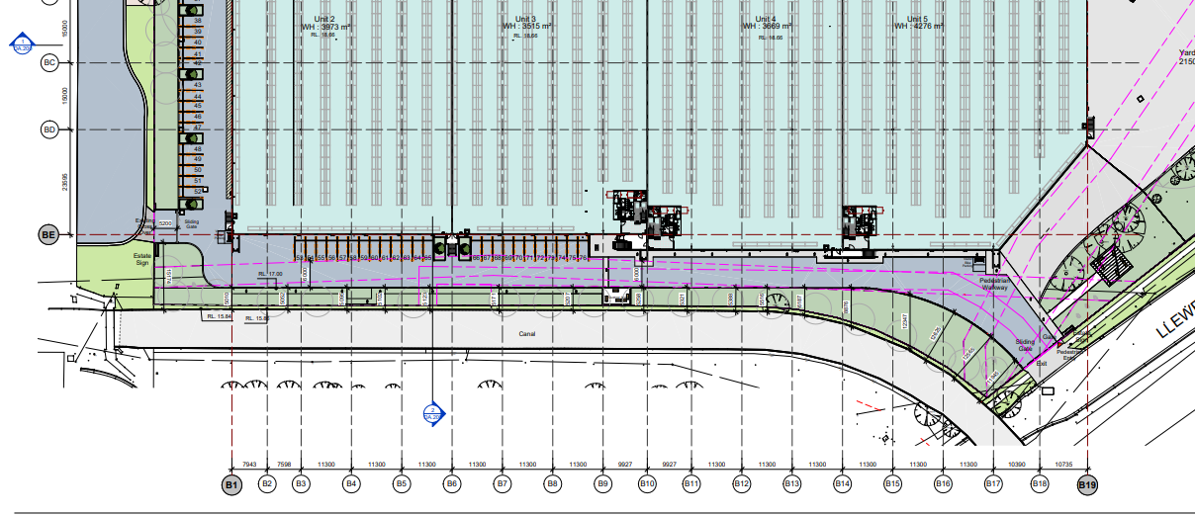
Figure 7: Setback - Source: Willowtree Planning

It should be noted that the applicant has amended the design and increased the setback from that which was originally submitted to Council. While a departure still remains, the applicant has provided the following justification for the noncompliance to the control:

- There is no realistic prospect that the relevant DCP objectives could be achieved in relation to the concrete lined stormwater drainage channel as a result of other recent development approvals in the vicinity of 1 Marple Avenue Villawood.

- The concrete lined channel does not comprise any significant biodiversity. A Flora and Fauna Assessment was prepared as part of the lodgement package and has identified the stormwater channel adjacent to the subject site to be a Strahler first order watercourse and has concluded that there is no Key Fish Habitat in proximity to the subject site and a BDAR is not recommended for the proposed works.

The applicant proposes the following reasons as to why re-naturalisation of the channel is either unrealistic or unviable. Thes are as follows:

- The Sydney Water sewer pipeline which runs parallel to the stormwater channel would be required to be relocated to facilitate the re-naturalisation of the channel. Consultation with Sydney Water would be required to ascertain their stance on the impacts to the sewer pipeline. The project hydraulic consultant has undertaken a review of the future outcome for the sewer pipeline and has highlighted that Sydney Water is unlikely to support retaining the pipeline given the slope of the land, the size of the asset and the impact of tree plantings on the asset.

- Ausgrid high voltage overhead power lines are located parallel to the stormwater channel and would be required to be relocated to facilitate the re-naturalisation of the channel. The natural batter required to form Council’s intended naturalised channel would result in the requirement of powerlines to be relocated due to their proximity to the existing channel retaining walls. Furthermore, the re-naturalisation of the channel would result in these power lines being located within the waterway which would never be accepted by Ausgrid as Clear accessways are required below all overhead powerlines.

- A Jemena gas pipeline runs perpendicular to the stormwater channel and is fixed to the pedestrian bridge located at the end of Shaddock Avenue. Major modifications to the pedestrian bridge and gas pipeline would be required to facilitate the re-naturalisation of the channel. Furthermore, Jemena would need to provide their consent for these works to be undertaken.

In considering the need for a 15 metre setback from the channel to the development along the site’s eastern boundary, the following recent decision should be taken into account:

373 Horsley Road, Milperra

On 3 August 2023, the Sydney South Planning Panel approved DA-650/2022 which proposed the demolition of existing structures, remediation of land, site preparation works and construction of 2 warehouse buildings for use as a warehouse and distribution centre including associated site servicing works, hardstand and landscaped areas, car parking, and supporting infrastructure.

The proposal included a revegetated setback to an adjacent stormwater channel (not the same channel as the one discussed in this report) which flows into the Georges River. The assessment report notes the following about the setback to the channel in relation to the subject DCP control:

The application proposes a varying setback from the top of the channel to the northern edge of the built form ranging from a minimum of 5.5m to a maximum of 18m (in the widest portion to the north west). A setback of 8 metres or more is provided for over half of the length of the northern boundary.

The northern setback proposes approximately 2150sqm of landscape riparian setback which will enhance the quality and aesthetic of the channel and the industrial area. The development as designed provides for a balanced approach to ensure adequate space is available for the establishment of a reasonable landscaped edge to the channel, whilst also responding to the site-specific situation of the locality to the west.

It is considered that the balance of the setback provided within this proposal is acceptable given the nature of the site and its surrounding context.

The setback approved can be seen below as a green strip running along the northern boundary of the development site:

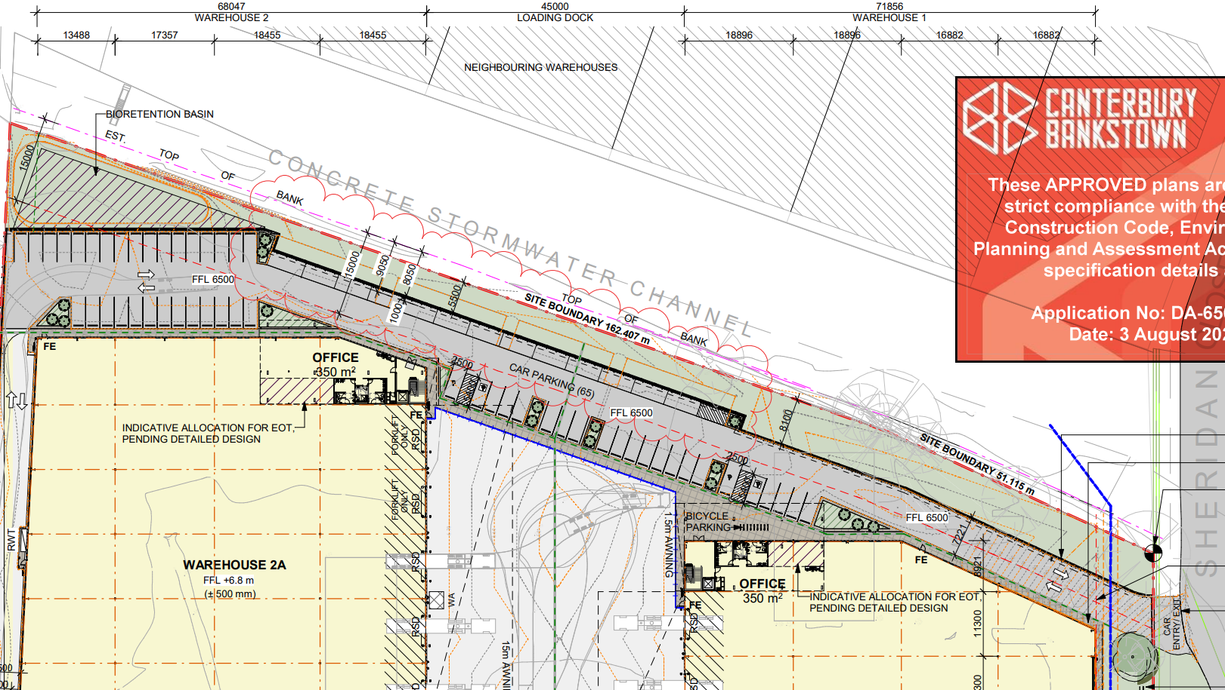
Figure 8: Stamped Plans for DA-650/2022
In approving DA-650/2022 the Panel approved a riparian corridor with an average width of 8 metres.

The consent authority must consider whether the application first complies with the DCP control, and if not, whether the non-compliance is worthy of support. To this aim, the development does not provide a complete 15-metre setback to the top bank of the stormwater channel meaning that the development does not comply however, the application has been reviewed by Council’s Biodiversity Officer who has agreed that the proposed setback would provide for a benefit to the area and is considered acceptable given the constrains present in re-establishing a natural riverbed in the locality and the approvals on nearby sites. On average, a 7.9 metre setback is proposed to the stormwater channel which is capable of hosting a variety of plant life to establish a suitably landscaped buffer to the channel. Considering the nature and characteristics of a riparian corridor, it can be said that the proposal provides a suitable outcome for the locality despite the technical non-compliance with the development control.

Chapter 9.1, Clause 2.12 and Clause 2.13: These clauses require certain rates of tree plantings along street frontages and within landscaped areas. The application is accompanied by an arborist report which makes recommendations for replacement plantings which has been reviewed by Council’s Tree Management Officer as suitable for the site and the plantings chosen, notwithstanding the non-compliance which may cause for canopy overcrowding based on the scale and spread of the proposed tree plantings.

Chapter 9.1, Clause 5.8: requires that a substation on site be located underground or integrated into the development and screened from view. The subject application proposes a substation which is located within the front landscaped setback. The existing substation on site is located within the flood zone and therefore Ausgrid have requested this substation be relocated to a more appropriate location as part of the redevelopment of the subject site. The new proposed substation would be located along the site’s frontage to Shaddock Avenue which forms one of the sites secondary frontages. The proposed location has been selected in consultation with Ausgrid and electrical engineering level 2 advice. The substation would not dominate the view of the subject site and would be partially shielded by vegetation which is proposed to boarder the substation. This location is the most appropriate as Shaddock Avenue would receive the least amount of pedestrian and vehicular traffic and ensure the functionality of the subject site is not compromised.

Chapter 9.1, 5.11: requires that the maximum height for a front fence not exceed 1.8 metres. This control seeks to establish a consistent character of fencing in an industrial area by controlling the size of fencing, in addition to other controls which restrict the design of fencing. The subject application proposes a maximum fence height of 2.4 metres, representing a 33% variation to the control. The application complies with controls regarding the design of fencing. The objective of the variation is to ensure the security of the facility which will operate 24 hours a day and to discourage unauthorised dumping of rubbish. As the site does not border another industrial site, the variation to the fence height would not be discernible as there would be no immediate transition between a 2.4 metre tall fence and a 1.8 metre tall fence. Notwithstanding the non-compliance, the proposal provides for an acceptable outcome within an establish industrial precinct and is worthy of support.

Development Contributions

The following contributions plan is relevant pursuant to Section 7.18 of the EP&A Act and have been considered:

- Canterbury Bankstown Local Infrastructure Contributions Plan 2022

- Section 4.15(1)(a)(iiia) – Planning agreements under Section 7.4 of the EP&A Act

There have been no planning agreements entered into and there are no draft planning agreements being proposed for the site.

- Section 4.15(1)(a)(iv) - Provisions of Regulations

The proposal is consistent with the relevant provisions of the Regulations.

  - Section 4.15(1)(b) - Likely Impacts of Development

The likely impacts of that development, including environmental impacts on both the natural and built environments, and social and economic impacts in the locality must be considered. In this regard, potential impacts related to the proposal have been considered in response to SEPPs, LEP and DCP controls outlined above and the Key Issues section below.

- Context and setting – The proposal is considered to be generally consistent with the context of the site, in that the proposed warehouse and distribution centre is appropriate in terms of bulk and scale and provides employment opportunities within an existing industrial area.

- Access and traffic – The proposed development has been assessed by Council’s Traffic division as well as Transport for New South Wales who have both considered the development suitable for the locality and that it would not bring about adverse impacts on traffic in the area.

- Utilities – The application is accompanied by substation advice from Ausgrid as well as having been referred to Ausgrid during the assessment process. The resultant development would not provide for adverse impacts on the utility infrastructure within the area.

- Contamination – as is demonstrated in the accompanying reports, the land is currently contaminated and can be made suitable for the proposed development.

- Natural hazards – the application is satisfactory in terms of information to allow the consent authority to determine that the development would not provide for unacceptable levels of hazards to both personal safety and life as well as economic impacts.

- Economic impact – the proposal would provide for an increase in economic activity by deliver modern, well-designed warehouse and distribution facilities in an existing industrial environment with good access to public transport.

- Site design and internal design – the proposal is appropriately set out on the site.

- Cumulative impacts – the application is accompanied by information which demonstrates that approval of the development would not result in adverse cumulative impacts including Council stormwater infrastructure, characteristics of floodwaters in the locality and the preservation of life and property.

Accordingly, it is considered that the proposal will not result in any significant adverse impacts in the locality as outlined above.

  - Section 4.15(1)(c) - Suitability of the site

The proposal is suitable for the site. The development proposes an appropriate bulk and scale as well as land use for the area. The development would result in the redevelopment of a currently underutilised site within an existing industrial precinct, supporting the region’s need for new warehousing facilities while avoiding adverse impacts on the locality.

  - Section 4.15(1)(d) - Public Submissions

No submissions were received.

  - Section 4.15(1)(e) - Public interest

Approval of the development will be within the public interest as demonstrated within this report.

- REFERRALS AND SUBMISSIONS

  - Agency Referrals and Concurrence

The development application has been referred to various agencies for comment as required by the EP&A Act and outlined below in Table 5.

There are no outstanding issues arising from these concurrence and referral requirements subject to the imposition of the recommendations of these agencies being adopted.

Table 6: Concurrence and Referrals to agencies
Agency | Concurrence/  referral trigger | Comments  (Issue, resolution, conditions) | Resolved
Concurrence Requirements (s4.13 of EP&A Act)
N/A | None | None | N/A
Referral/Consultation Agencies
Electricity supply authority | Section 2.48 – State Environmental Planning Policy (Transport and Infrastructure) 2021  Development near electrical infrastructure | Ausgrid does not object to the proposed development. | Y
Rail authority | Section 2.97 – State Environmental Planning Policy (Transport and Infrastructure) 2021  Development land that is in or adjacent to a rail corridor. | Recommended conditions of consent provided. | Y
Transport for NSW | Section 2.122 – State Environmental Planning Policy (Transport and Infrastructure) 2021  Development that is deemed to be traffic generating development in Schedule 3. | TfNSW has reviewed the application and has no requirements as the proposed development will not have a significant impact on the classified road network. | Y
Integrated Development (S 4.46 of the EP&A Act)
Natural Resources Access Regulator | 91(3) – Water Management Act 2000  water use approval, water management work approval or activity approval under Part 3 of Chapter 3 | For the purposes of the Water Management Act 2000 (WM Act), the proposed works are exempt from the need to obtain a controlled activity approval and no further assessment by this agency is necessary. | Y
WaterNSW | 91(2) – Water Management Act 2000  water use approval, water management work approval or activity approval under Part 3 of Chapter 3 | For the purposes of the Water Management Act 2000, no further investigation is required by WaterNSW. | Y

  - Council Officer Referrals

The development application has been referred to various Council officers for technical review as outlined Table 6.

Table 7: Consideration of Council Referrals
Officer | Comments | Resolved
Engineering | Council’s Engineering Officer reviewed the submitted stormwater concept plan and has provided conditions of consent. | Y
Traffic | Council’s Traffic Engineering Officer reviewed the proposal and raised concerns in relation to vehicle manoeuvring which were resolved through amended plans. | Y
Building | Council’s Building Surveyor reviewed the proposal and provided conditions of consent. | Y
Health | Council’s Environmental Health Officer reviewed the proposal including the DSI and RAP and has provided conditions of consent for the proposal. | Y
Waste | Council’s Resource Recovery Officer reviewed the proposal and provided conditions of consent. | Y
Tree | Council’s Tree Management Officer reviewed the proposal including the aboricultural report and provided conditions of consent. | Y
Assets | Council’s Assets Officer has reviewed the proposal and provided conditions of consent. | Y
City Plan & Transformation | Council’s Biodiversity officer has reviewed the proposal and agrees that the proposal is consistent with the intent of the applicable controls. | Y
The outstanding issues raised by Council officers are considered in the Key Issues section of this report.

  - Community Consultation

The proposal was notified in accordance with the Council’s Community Participation Plan from 6 December 2023 until 17 January 2024. The notification included the following:

- An advertisement in the local newspaper [Torch];
- A sign placed on the site;
- Notification on a website;
- Notification letters sent to adjoining and adjacent properties (42 affected properties);
- Notification on the Council’s website.

The Council received a total of zero submissions.

- KEY ISSUES

At lodgement, the application contained a number of key issues which are outline below, all of which have been addressed satisfactorily.

  - Flooding

- Flooding – Reporting – Details of the following are required:

- Description of the LiDAR data including the date;
- Model grid resolution used;
- Rainfall losses assumption;
- Process of determining the critical duration (either based on flows or levels) and the selection of the temporal pattern if the ARR 2019 approach was used;
- Implementation of various drainage structures in the model including pits and pipes, open channel and the downstream culvert structures, as well as where the details (i.e. dimensions, invert levels) were sourced from;
- Velocity mapping for pre and post development conditions;
- Afflux mapping in terms of flow velocity changes;
- Complete set of flood maps for Rev C of the Flooding and Stormwater Plan report.

- Flooding – Modelling Approach – Clarification is required on the adopted hydrological modelling approach, whether the direct rainfall approach was used or runoff hydrographs generated by XP-STORM were applied in the hydraulic model.

- Flooding – Hazard Mapping – Flood hazard shall be mapped in accordance with the flood hazard curve found in ARR 2019 which has six (6) categories, i.e. “H1” to “H6”, rather than the three (3) categories recommended in the NSW Floodplain Development Manual.

- Flooding – PMF - Flood modelling and assessment will need to be undertaken for the Probable Maximum Flood (PMF) event, including afflux and hazard mapping. Recommendation on suitable flood emergency response shall also consider the PMF flow behaviour within and around the site.

- Flooding – Afflux Reporting – The afflux mapping provided in Rev B of the Flooding and Stormwater Plan seems to indicate a cut off threshold of 0.1m in the mapping of the difference between pre and post development flood levels. The changes to flood levels below the 0.1m threshold shall also be mapped and the magnitude of impacts within and around the site be quantified in the report.

- Flood Planning Levels – A flood planning level (FPL) of RL 18.0 was reported. However, the 1% AEP post-development flood mapping provided in Rev B of the Flooding and Stormwater Plan indicate contours showing peak flood levels ranging from RL 17.5 to 18.0 at the western corner of Warehouse 2, which would result in a FPL above RL18.0. Whilst for Warehouse 1, the adjacent 1% AEP peak flood levels range up to RL 20.0 to 20.5, which is significantly above the reported FPL. It is noted for Warehouse 1 the flood affectation is likely to be caused by overland flow in the 1% AEP event so consideration should be given to providing a freeboard from the surrounding flood level to prevent any nuisance flooding from entering the warehouse.

This issue has been resolved.

  - Stormwater Management

- Stormwater – OSD - In accordance with Canterbury-Bankstown DCP 2023 – Chapter 3.1 Section 4, non-residential development will require OSD regardless of the impervious area before and after the development.

- Stormwater – Survey - The applicant shall carry out survey via non-destructive method to confirm the exact physical location of Council’s stormwater assets within the site including the pipe/culvert size and invert level as part of this assessment.

- Stormwater – Easement - A drainage easement in favour of Council shall be created over Council’s pipe and culvert traversing the site for the purpose of constructing and maintaining stormwater drainage structures. The easement must be centrally located over the drainage pipe and culvert, and the width must be in accordance with Canterbury-Bankstown DCP 2023–Chapter 3.1 (Table 3a: Minimum easement widths).

- Stormwater – Easement – Council prohibits the installation of most types of structures including trees, permanent fixtures, wall within drainage easements. Construction of light demountable structures can be considered, subject to assessment of flooding impacts and any existing utilities or pipelines located within the easement.

- Stormwater – Pre and Post-Construction CCTV Report - To ensure Council’s stormwater infrastructures are adequately protected, a pre and post construction CCTV report on the existing stormwater pipeline, culvert and pits in the vicinity of the proposed development shall be submitted to Council.

This issue has been resolved.

  - Other

- Building Components - All structures shall have flood compatible building components below the 1% AEP plus freeboard in accordance with Canterbury-Bankstown DCP 2023 – Chapter 2.2.

- Structural Soundness - Applicant shall demonstrate that the structure can withstand the forces of floodwater, debris, and buoyancy up to and including a 1% AEP flood plus freeboard, or up to the PMF if required to satisfy the evacuation requirement.

- Flood Emergency Response Plan – The applicant shall prepare a site-specific flood emergency response plan to inform occupants of the site flood risks and suitable emergency response before, during and after a flood event.

- Landscaped Setback - Aligned with CBCITY DCP control, landscaped setback of 15 meters is mandated. This requirement is established in consideration of the Council's prospective intention to re-naturalise the channel as part of a catchment-wide strategy.

This issue has been resolved.

- CONCLUSION

This development application has been considered in accordance with the requirements of the Environmental Planning & Assessment Act 1979 and the Regulations as outlined in this report. Following a thorough assessment of the relevant planning controls and the key issues identified in this report, it is considered that the application is worthy of support.

The application proposes a compliant built form outcome and land use and is generally consistent with what is expected to be provided within an established industrial zone despite some departures from the DCP. While not complying with the required 15-metre riparian setback, the proposed average 7.9 metre setback will be able to establish a well-landscaped buffer to the adjoining concrete-lined stormwater channel.

An issue consistently raised by Council has been how the proposal will adequately dispose of floodwater and stormwater it attracts but based on the information accompanying the application, Council has determined that the development would have a neutral or beneficial impact on stormwater characteristics within the vicinity.

Based on the assessment contained within this report, it is recommended that the application be approved subject to recommended conditions of consent.

